Tutorial 1
Trace and explain the HTTP request-response cycle using browser developer tools (Network tab) for a sample website.
Network tab after refreshing the page.
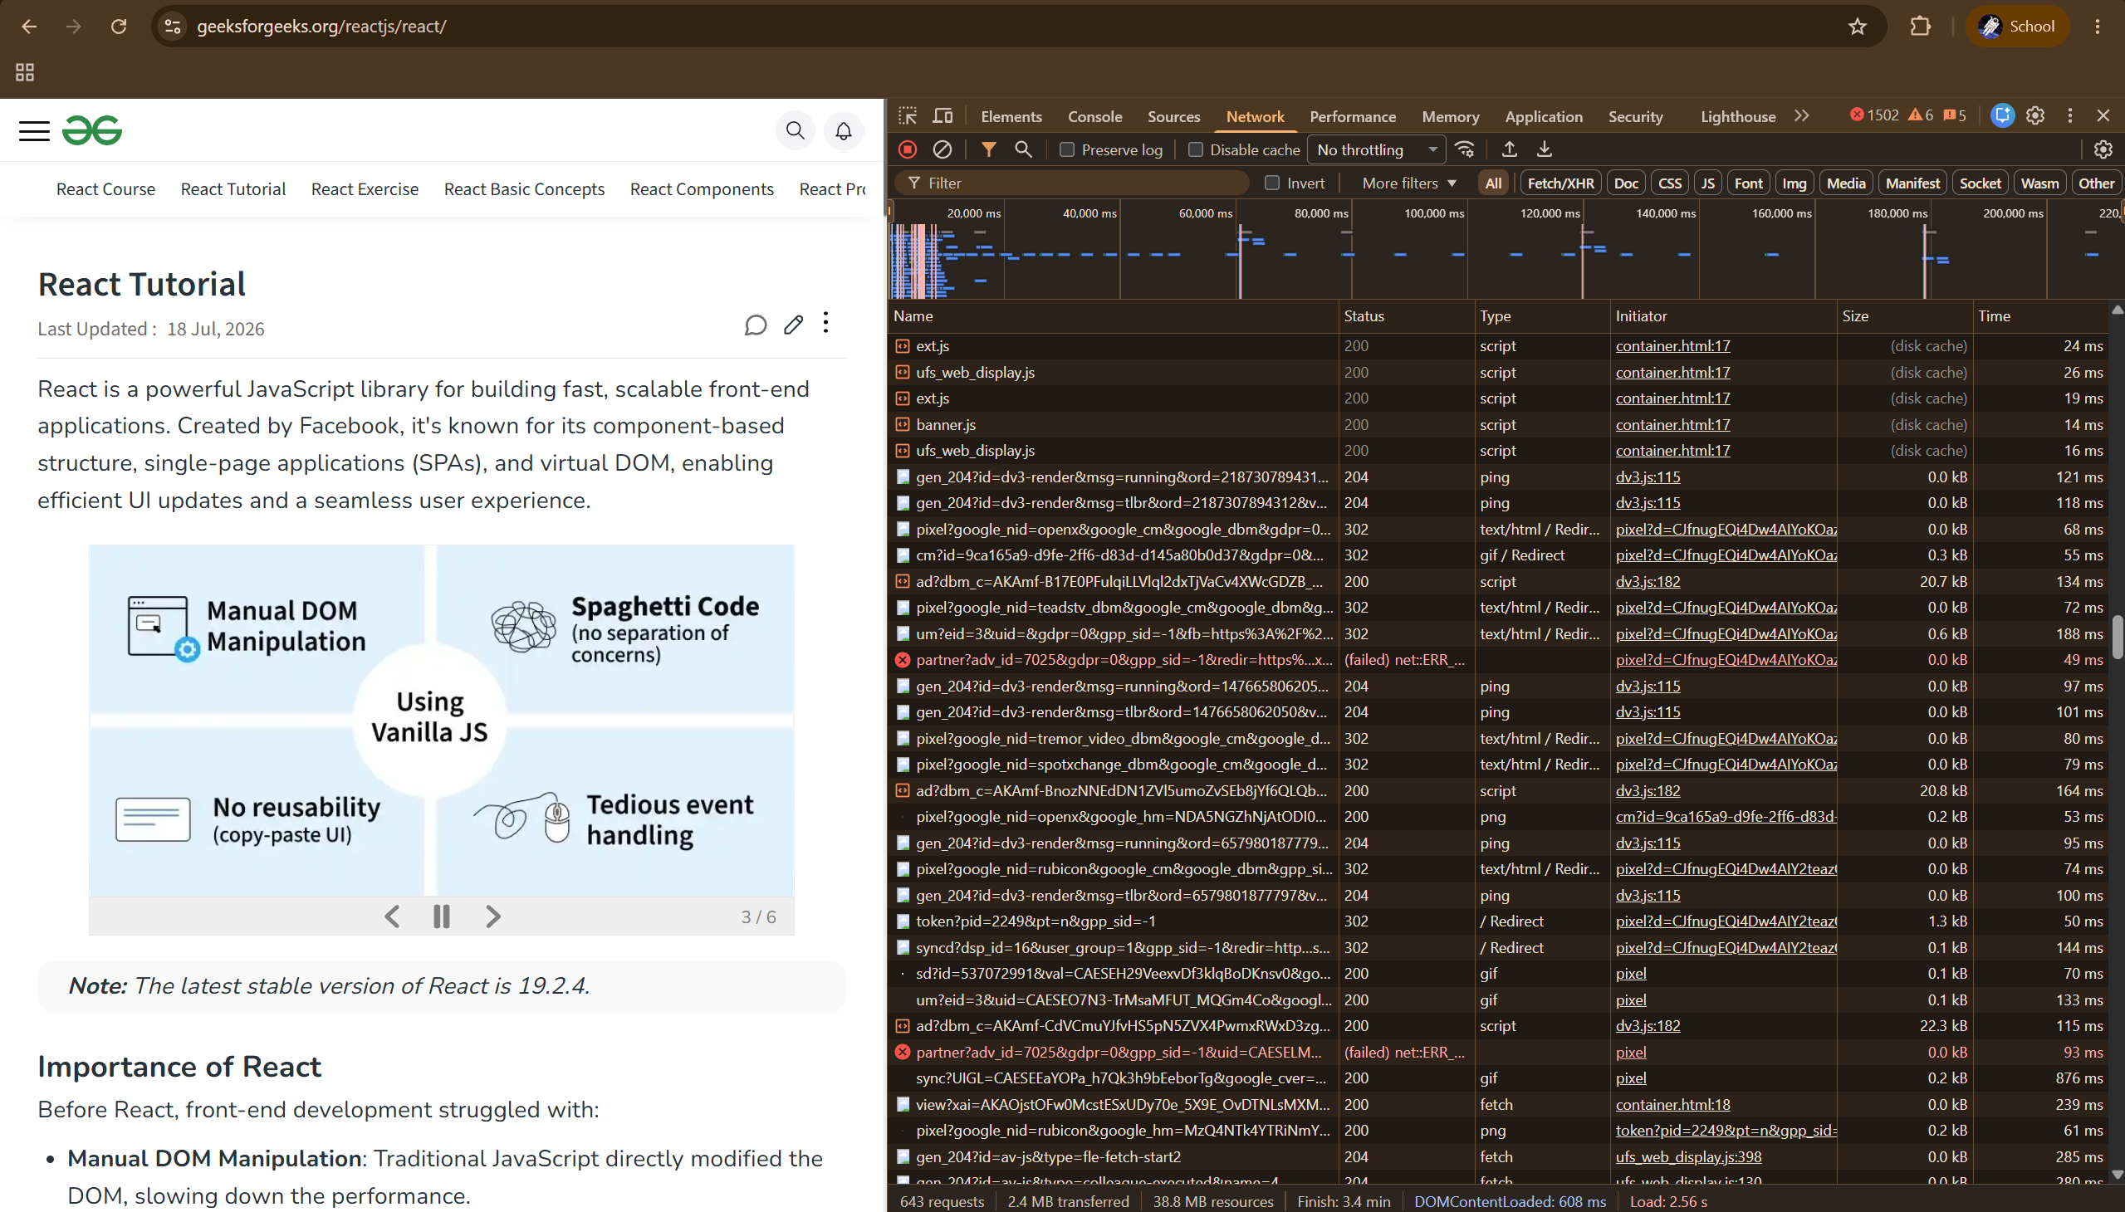
Main request → Headers, showing Request URL, GET, and Status Code
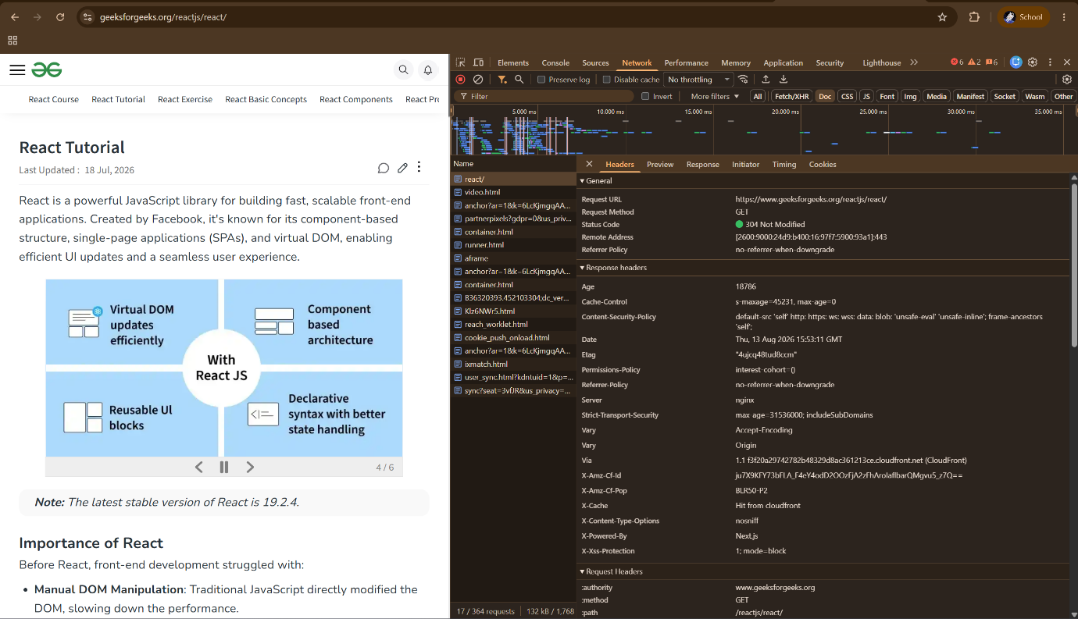

Main request → Response, showing the returned HTML.
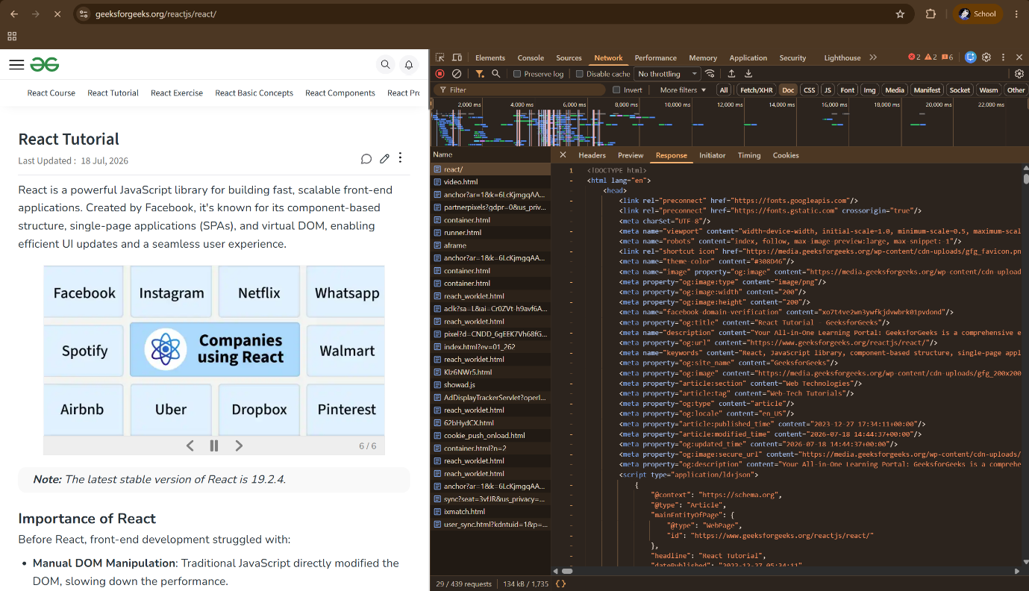
Main request → Timing, showing the request timing.
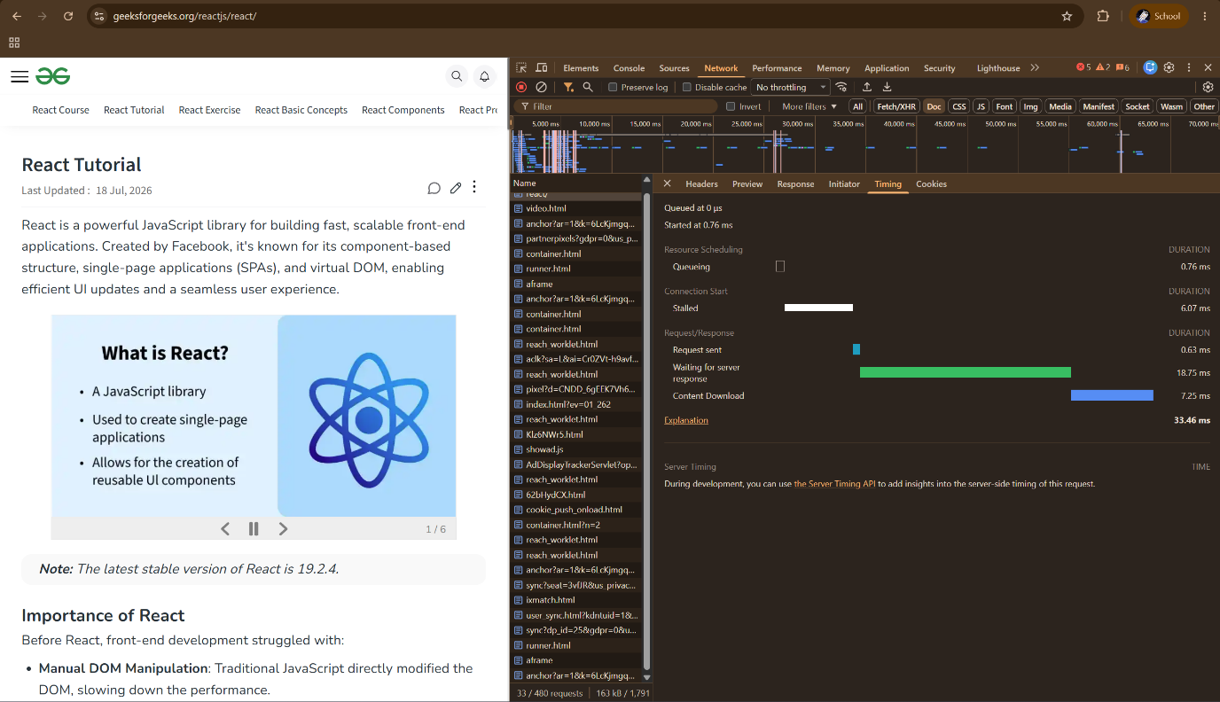
I opened the GeeksforGeeks React Tutorial page and used Chrome Developer Tools to observe its HTTP request response cycle. In the Network tab, I selected the main react/ document request and observed that the browser used the GET method to request the webpage. The server returned a 304 Not Modified response, meaning the browser could use the previously cached version because the webpage had not changed. The Response tab showed the HTML content received by the browser, while the Timing tab showed the different stages such as sending the request, waiting for the server response, and downloading the content. This helped me understand how the browser communicates with the server and loads a webpage through HTTP.

Tutorial 2
Identify and fix layout issues in HTML/CSS code, including alignment, spacing, and responsiveness using Flexbox and Grid.
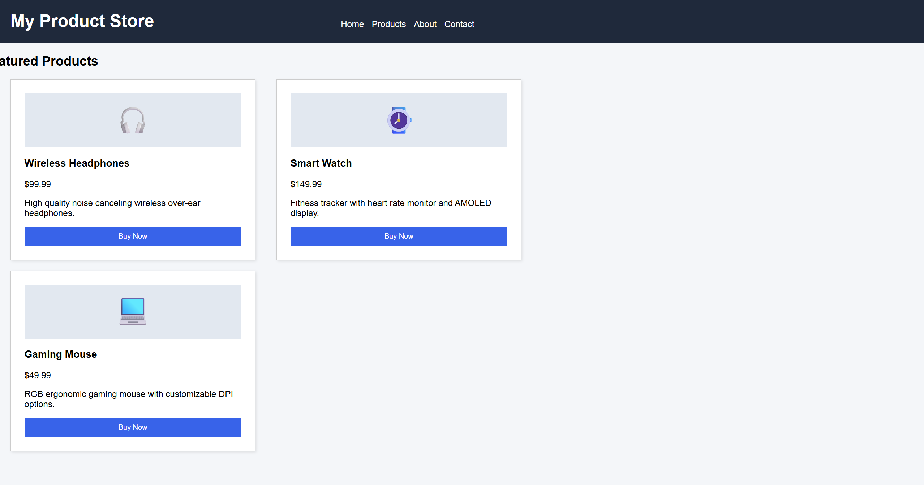
- Observed Issues:
  - Fixed container width (1200px) causing horizontal scrollbars on smaller screens.
  - Header links misaligned due to hardcoded margin-left.
  - Cards overlapping or wrapping unevenly due to inline-block + fixed width: 400px.
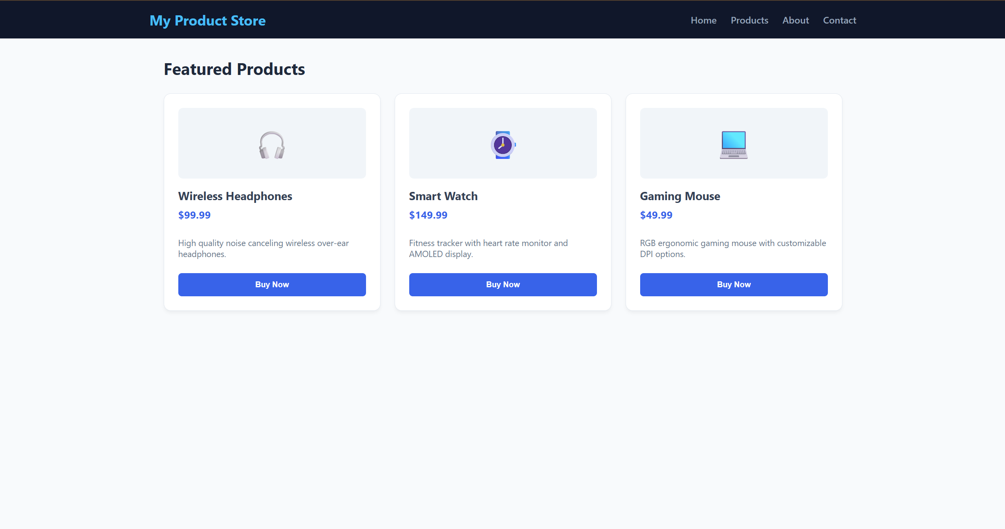
Layout Fixes
- Flexbox Header: Switched from fixed inline-block positioning to display: flex with justify-content: space-between and align-items: center.
- CSS Grid Layout: Product cards container (.product-list) now uses display: grid; grid-template-columns: repeat(auto-fit, minmax(280px, 1fr)); gap: 1.5rem; for automatic row and column wrapping.
- Fluid Layout Container: Replaced hardcoded fixed width (width: 1200px) with fluid max-width: 1200px and dynamic centering.
- Responsiveness: Added @media (max-width: 640px) media query rule to cleanly stack header items on mobile screens.

Tutorial 3
Solve JavaScript problems involving DOM manipulation, event handling, dynamic updates, and form validation.
Initial Form
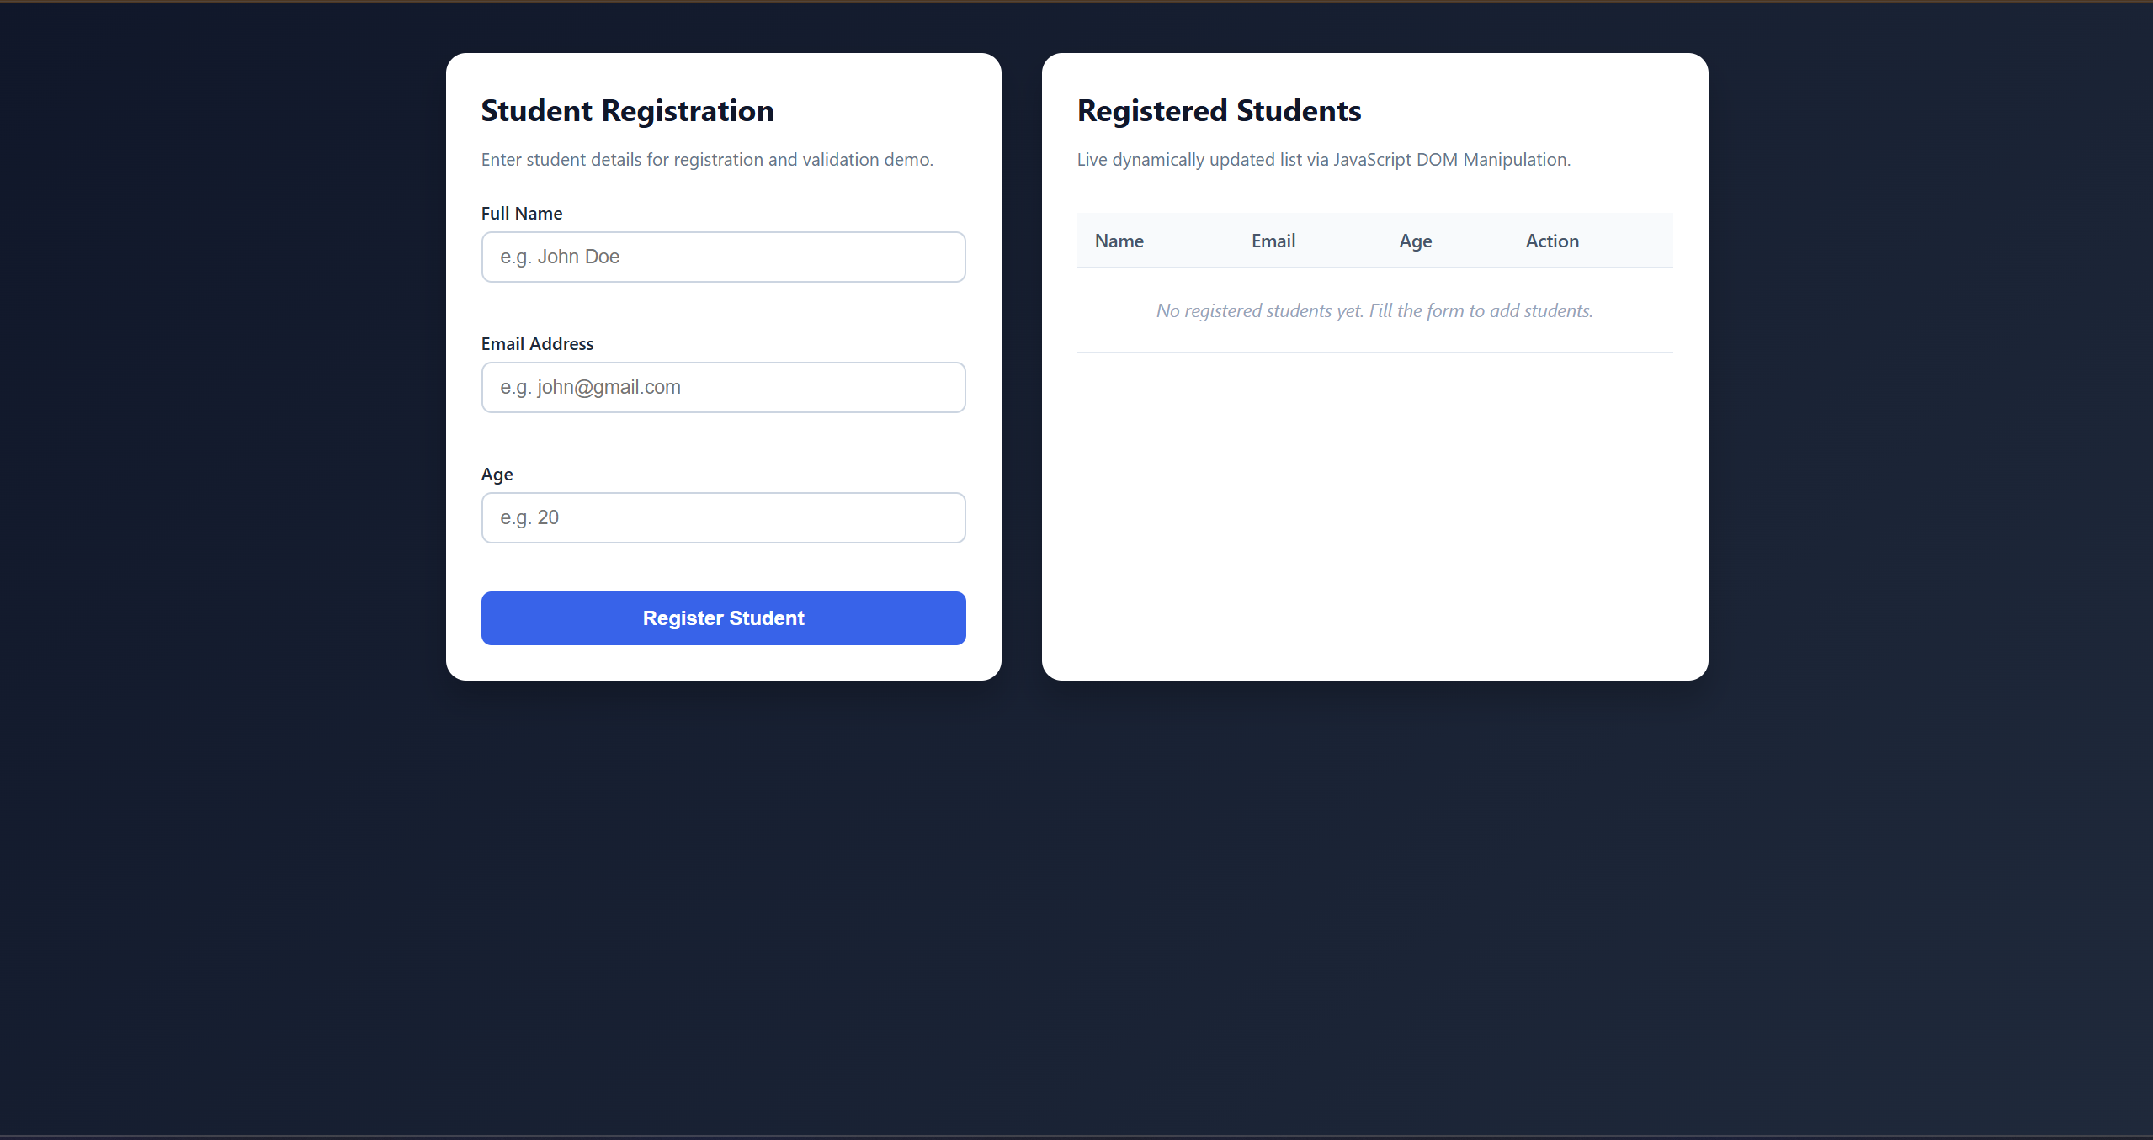
Form Validation
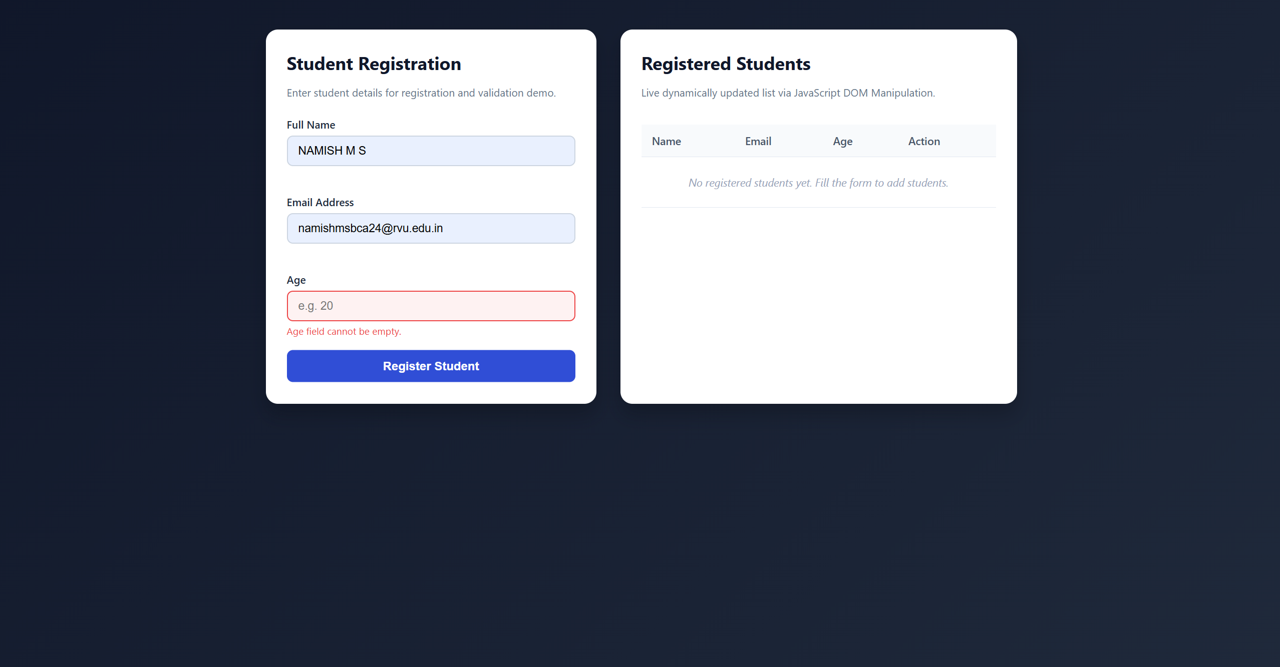

Successful Submission and Multiple Dynamic Updates
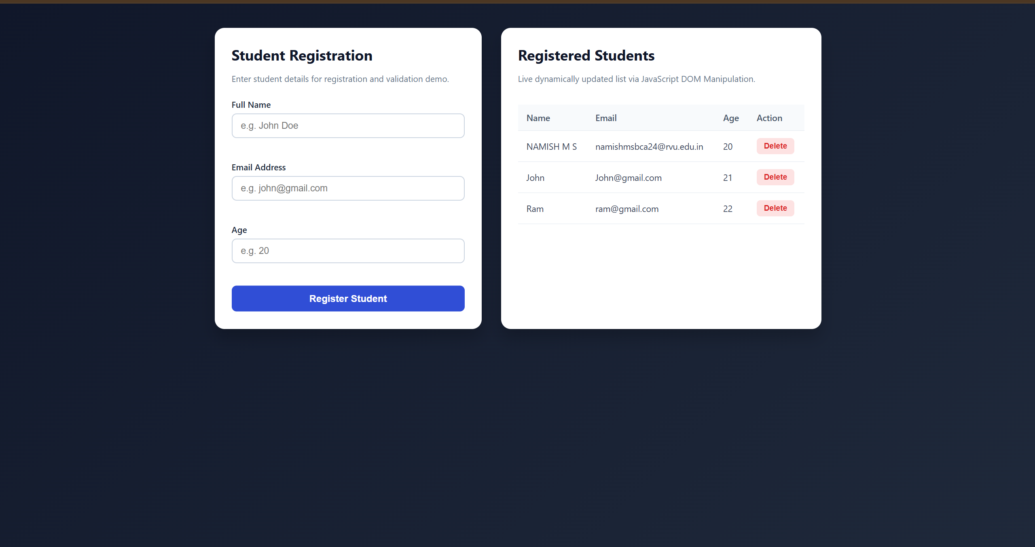
This practical demonstrates JavaScript DOM manipulation, event handling, dynamic updates, and form validation. A student registration form was created to collect student details and validate the entered information. When invalid data is entered, an error message is displayed. After valid details are submitted, the student is dynamically added to the registered students table without refreshing the page. This shows how JavaScript can interact with webpage elements and update the content based on user actions.

Tutorial 4
Analyze a UI and decompose it into reusable React components with proper hierarchy.
Final UI complete React webpage.
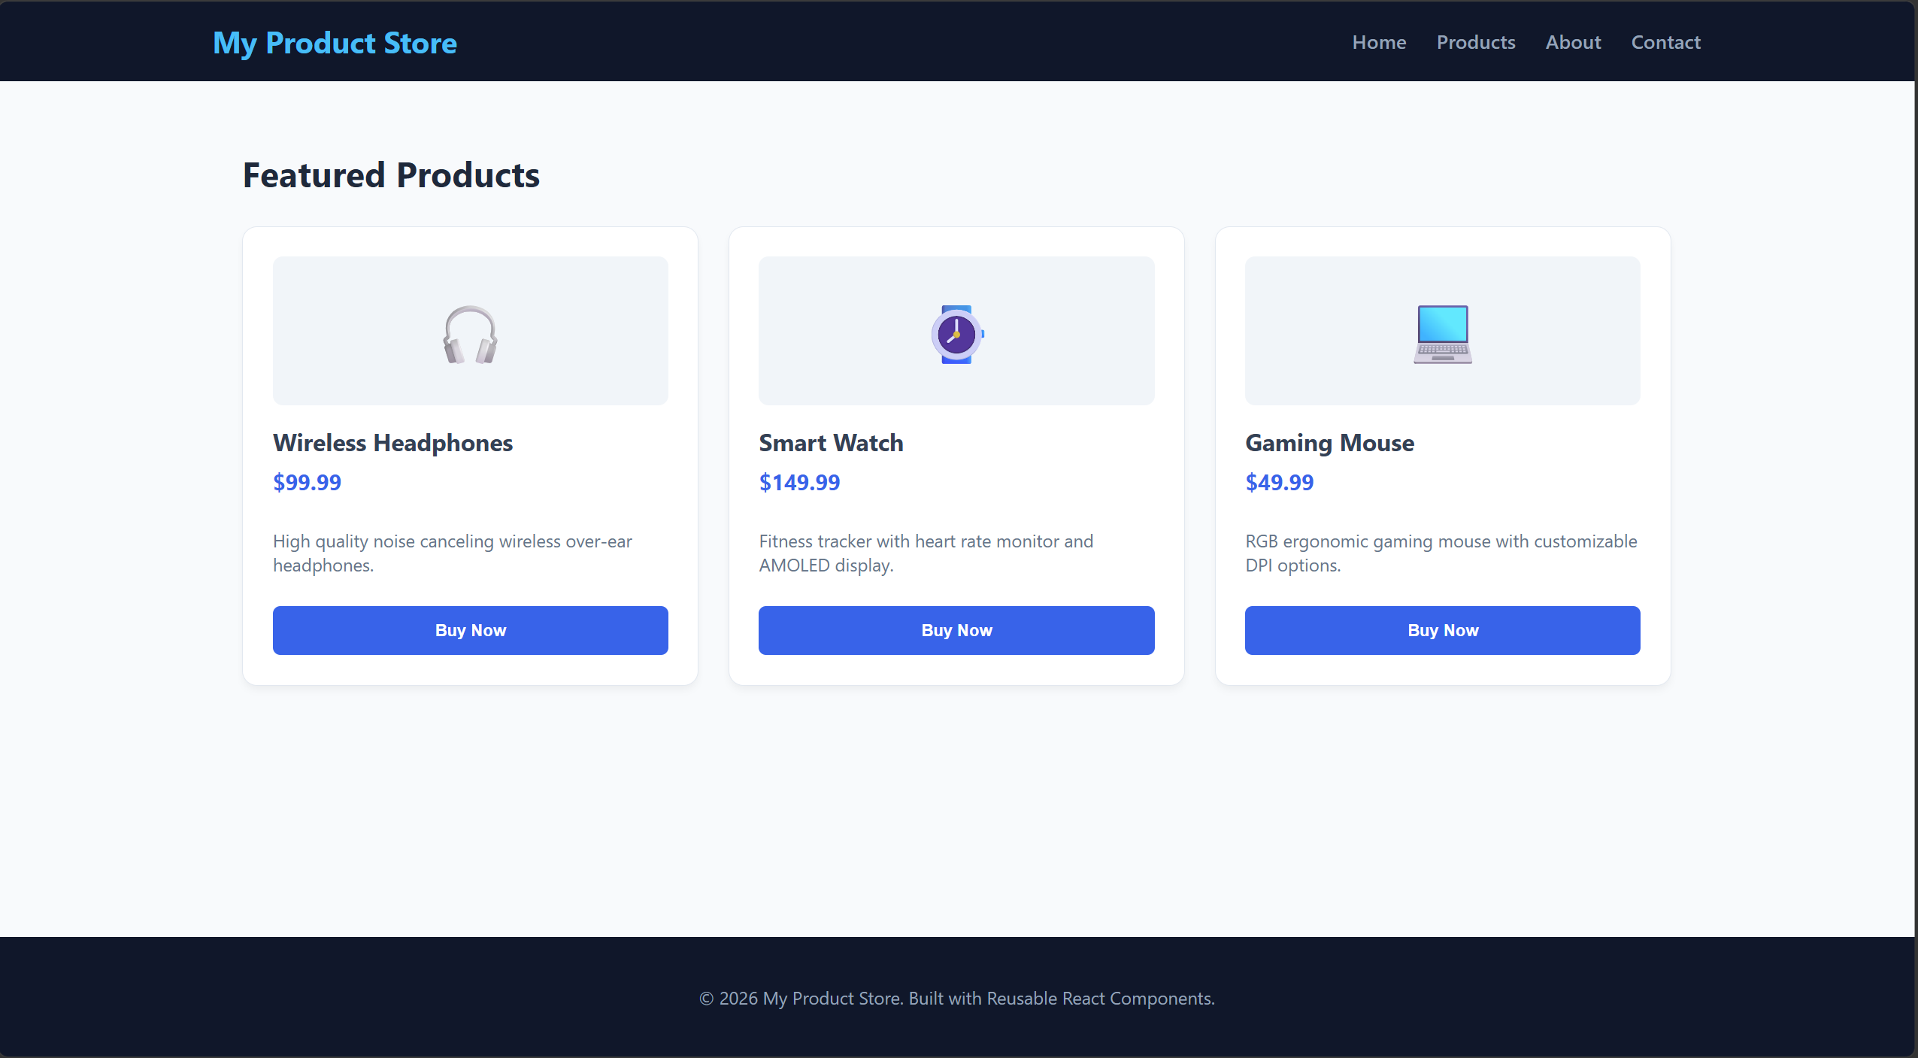
Project/component structure
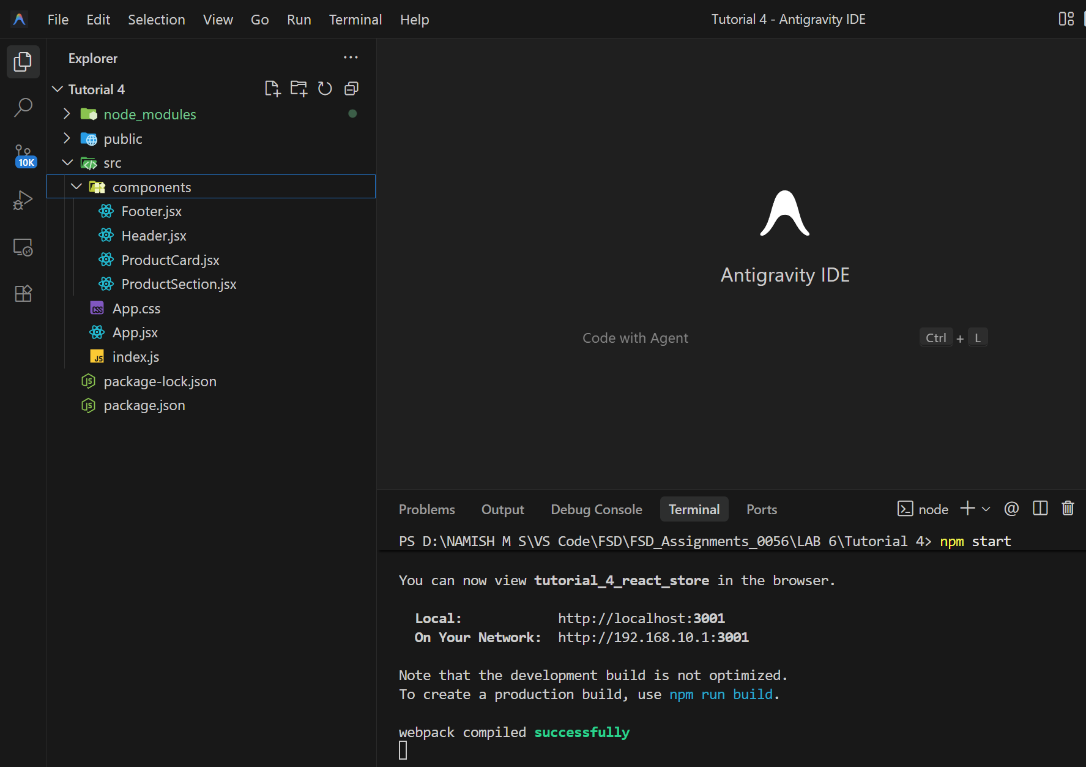
Reusable component code
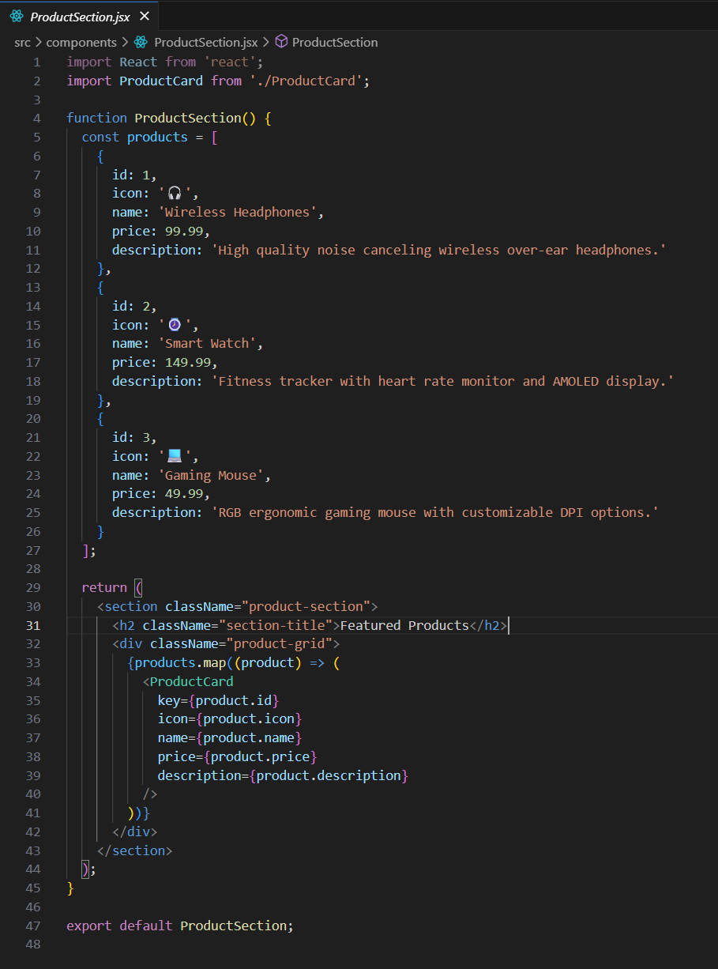
In this tutorial, the product store UI was divided into reusable React components such as Header, ProductSection, ProductCard, and Footer. The ProductSection manages the product data and displays each product using the reusable ProductCard component. This component-based structure makes the code cleaner, easier to maintain, and allows the same UI elements to be reused across the application.

Tutorial 5
Implement and trace React state updates and component interactions in a given scenario.
